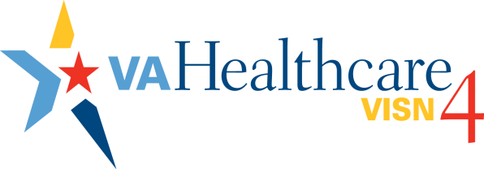

VA Healthcare – Veterans Integrated Service Network 4 is a network of 9 VA medical centers and 41 community-based outpatient clinics. In fiscal year 2015, VISN 4 served 321,661 Veterans from across the Nation, primarily from throughout Pennsylvania, West Virginia, Delaware, New Jersey, New York and Ohio. With an operating budget of more than $2.7 billion and a staff of more than 14,000, VISN 4 is working hard to provide personalized, proactive, patient-driven health care.

Mission Statement

To serve and honor our Veterans by continuing President Lincoln's promise “to care for him  
who shall have borne the battle, and for his widow, and his orphan.”

Vision Statement

To provide Veterans the world-class benefits and services they have earned — and to do so by adhering to the highest standards of compassion, commitment, excellence, integrity, accountability and stewardship.

VA Core Values

I CARE: Integrity, Commitment, Advocacy, Respect and Excellence

**OPERATIONS | FISCAL YEAR 2015**

**Veterans Served 321,661**

Women Veterans 17,393

**Workload Snapshot**

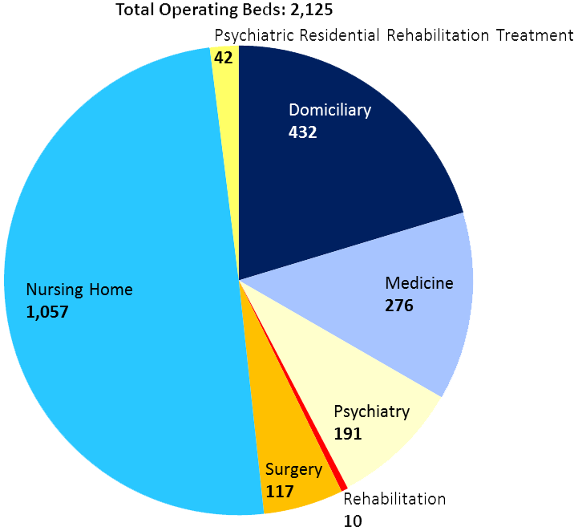

**Outpatient Visits 3,709,986**

**Prescriptions Filled 6.71 million**

*Louis A. Johnson VAMC in Clarksburg, West Virginia was realigned to VISN 5 effective October 1, 2015.   
As a result, data from this facility is included in the VISN 4 statistics shown here.*

**Financial Snapshot**

Total Budget $2,701,419,000

**$**

Gifts & Donations Received $4,479,571.52

Lands & Structures $68,233,000

New Equipment $31,428,000

**Workforce Snapshot**

**Total Employees 14,099**

****Veterans 4,015

Nurses 2,844

Physicians 1,076

**Volunteers 3,886**

**Research Snapshot**

**4 Sites:** Coatesville VA, Philadelphia VA,   
VA Pittsburgh Healthcare System, Wilkes-Barre VA

Projects 513

Investigators 260

Funding $45,673,497

**VA Healthcare – VISN 4**

**FY15 TOP ACCOMPLISHMENTS**

Telehealth

* VISN 4 has partnered with six universities, a vocational trade school, a homeless shelter, and three other residential treatment facilities to help Veterans connect with their VA providers using video teleconferencing.
* Philadelphia VA's Dr. Phillip Gehrman provides sleep insomnia groups to DoD, connecting with active duty marines at Camp Lejeune, with great outcomes reported.

Mental Health & Homeless Programs

* From FY12 through FY15, VISN 4 assisted 8,488 homeless Veterans in finding permanent housing; 2,846 of these occurred in FY15.
* Lebanon (FY15) and Philadelphia (FY16, Q1) were congratulated with effectively ending Veteran homelessness in their local communities.
* VISN 4 joined the “Integrated Reach Database System/Perceptive Reach” pilot; this work will test a software application package that leverages VHA clinical data to identify individuals who may be at elevated risk for adverse events.
* With the close of FY15, VISN 4 wrapped up the gun lock initiative. There were a total of 282,213 letters mailed to Veterans and 162,549 locks distributed.
* VISN 4 Mental Health programs scored above the national average on a comprehensive quality metric for mental health programs (SAIL).
* VA Pittsburgh Healthcare System's Tele-Mental Health Hub provided services to Veterans at six other VISN 4 sites and multiple locations in VISN 8 throughout FY15.
* VISN 4 had strong access to mental health care. The national average on the metric assessing the percentage of new patients seen within 30 days of the preferred date was 98%; VISN 4’s FY15, Q3 score was 99%.
* VISN 4’s FY15 score on a metric for following up with patients discharged from acute psychiatry beds within seven days was 86%; the target was 80%.

[www.visn4.va.gov](http://www.visn4.va.gov) 412-822-3316

Access

* VISN 4 created nearly 84,982 authorizations for Veterans to receive care in the private sector from November 12, 2014, through November 11, 2015. This represents a 3.28 percent decrease in authorizations when compared to the same period in 2013/2014.
* VISN 4 completed 97.17 percent of appointments in October 2015 within 30 days of the clinically indicated or Veteran’s preferred date; 91.94 percent within 14 days; 87.11 percent within 7 days; and 73.87 percent were actually completed on the same day.
* VISN 4 completed more than 2,492,878 appointments from November 1, 2014, through October 31, 2015. This represents an increase of 60,029 more appointments than were completed during the same time period in 2013/2014.

Special Events & Recognition

* The James E. Van Zandt VAMC received a Top 25 Award from Practice Greenhealth, as well as a Top Ten Circle of Excellence Award for water conservation. (They were the first VA to ever win the Top 25 Award last year.)
* Erie VAMC was ranked by the VA Strategic Analytics for Improvement and Learning Program as one of the Highest Performing Hospitals in Health Quality for 2015.
* In a national survey, Lebanon VAMC was ranked among the top ten educational sites within the Department of Veterans Affairs.
* All nine VISN 4 medical centers earned a Gold Cornerstone Recognition Award.

